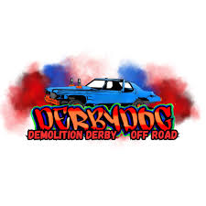
DERBYDOG INC
PG 1 of 1
DEMOLITION DERBY
ROUGH TRUCK
6/22/26

QUESTIONS?
TEXT: -JEREMY HEJDUK 440-223-4723

All participants must sign a waiver of liability.
No refunds will be given if the vehicle cannot run or is deemed illegal to run.
All decisions by Derbydog officials are final.

- 18 years or older, any classes that allow youth drivers must have parental consent signed liability form.
- All vehicles must contain DOT approved seat belts and seat must be securely fastened to the floor.
- All airbags must be disconnected or removed.
- All participants must wear DOT approved helmet (full-face recommended, with chin strap) and eye protection.
- All vehicles must be in good mechanical condition.
- All vehicles must have functional brakes -Street legal tires only (no tractor tires).
- Fuel must be gasoline or diesel only.
- Remove all loose items from vehicle.
- Roll bar/cage permitted
- Fire extinguisher in vehicle recommended
- Fire suit recommended
- No passengers
- Vehicles must have original firewall and floor in original location
- Battery can be relocated, securely mounted – preferably in battery box

**Upon visual inspection of vehicles, if they don’t seem to have a stock “from factory” appearance, you will not be permitted to run** (stock entry class only)
Rough Truck Series -
2 Runs Allowed – Best Time of 2 Runs
*Laps unfinished result in DNF
*Each cone hit will add 2 seconds to final time
*Missed jumps will add 5 seconds to final time

